How to Use the Softlayer VPN
Note: If you provisioned an Instance on the Private Network (a 10.x.x.x address), you will need to VPN into Softlayer to access the Instance.
Step 1: Visit: http://www.softlayer.com/VPN-Access and Select the VPN portal that matches your Instance.
Step 2: Log into the VPN website using your IBM ID and the password: IBMDem0s!
Step 3: Once you have successfully logged into the VPN website, you may be prompted several times by Java and your browser to allow the VPN. Be sure to accept all security and browser popups that appear, otherwise the installation will fail.
Step 4: The VPN website should state you are connected and you should now be able to reach your Instance.
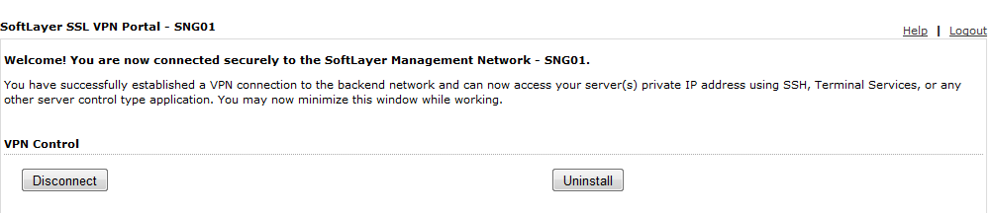
Note: The latest versions of Mozilla Firefox and Google Chrome are incompatible with the SoftLayer VPN due to a Java change that occurred earlier this year. If you experience greyed out username/password fields when accessing the SoftLayer VPN site, please use the following link to access the Standalone client.
http://knowledgelayer.softlayer.com/articles/standalone-vpn-clients-windows-linux-and-mac-os-x

